**Assignments based on web application development using JSP**

1. Create a Telephone directory using JSP and store all the information within a database, so that later could be retrieved as per the requirement. Make your own assumptions.  
2. Write a JSP page to display the Registration form (Make your own assumptions)  
3. Write a JSP program to add, delete and display the records from StudentMaster (RollNo, Name, Semester, Course) table.  
4. Design loan calculator using JSP which accepts Period of Time (in years) and Principal Loan Amount. Display the payment amount for each loan and then list the loan balance and interest paid for each payment over the term of the loan for the following time period and interest rate:  
a. 1 to 7 year at 5.35%  
b. 8 to 15 year at 5.5%  
c. 16 to 30 year at 5.75%  
5. Write a program using JSP that displays a webpage consisting Application form for change of Study Center which can be filled by any student who wants to change his/ her study center. Make necessary assumptions  
6. Write a JSP program that demonstrates the use of JSP declaration, scriptlet, directives, expression, header and footer.  
7. Write a JSP program that demonstrates the use of session or cookies.

**Web application development using JSP:**

Open Eclipse-> go to file-> new-> select Project-> select Dynamic web Project-> next-> project name-> next-> next-> finish.

Go to jsplogin-> new-> other-> select HTML File-> file name-> next-> finish.

Go to jsplogin-> new-> other-> select JSP File-> file name-> next-> finish.

Setp1:

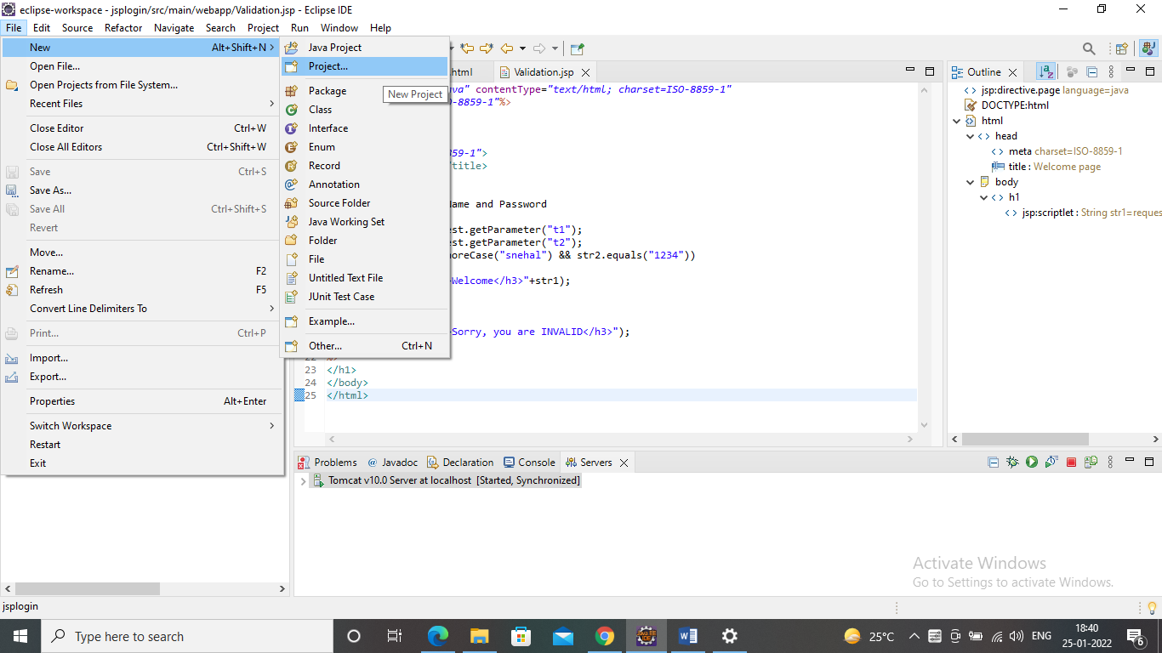

Step2:

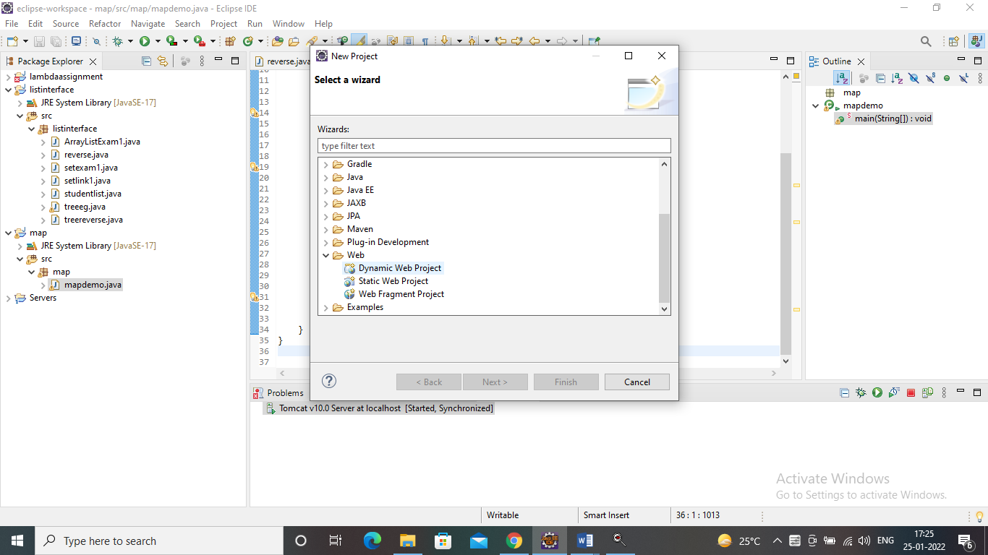

Step3:

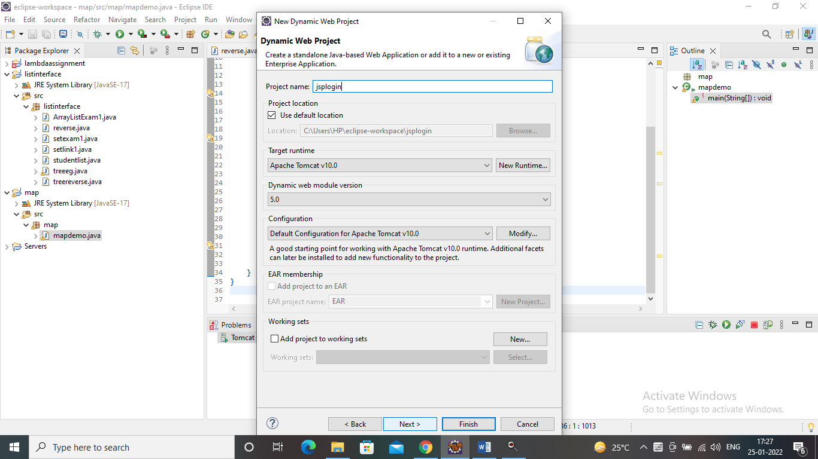

Step4:

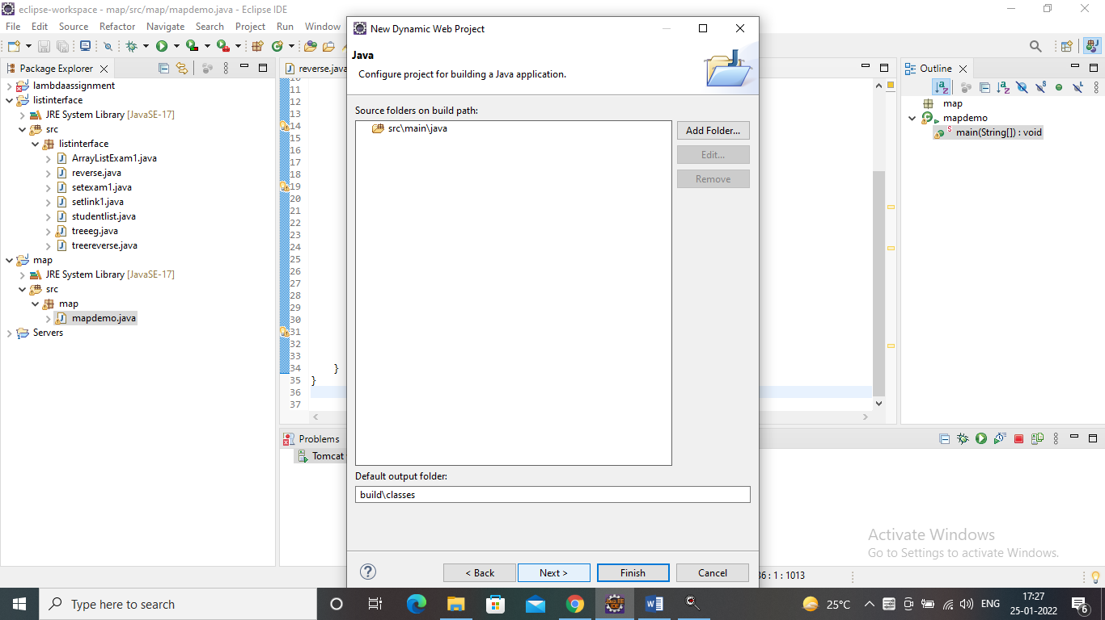

Step5:

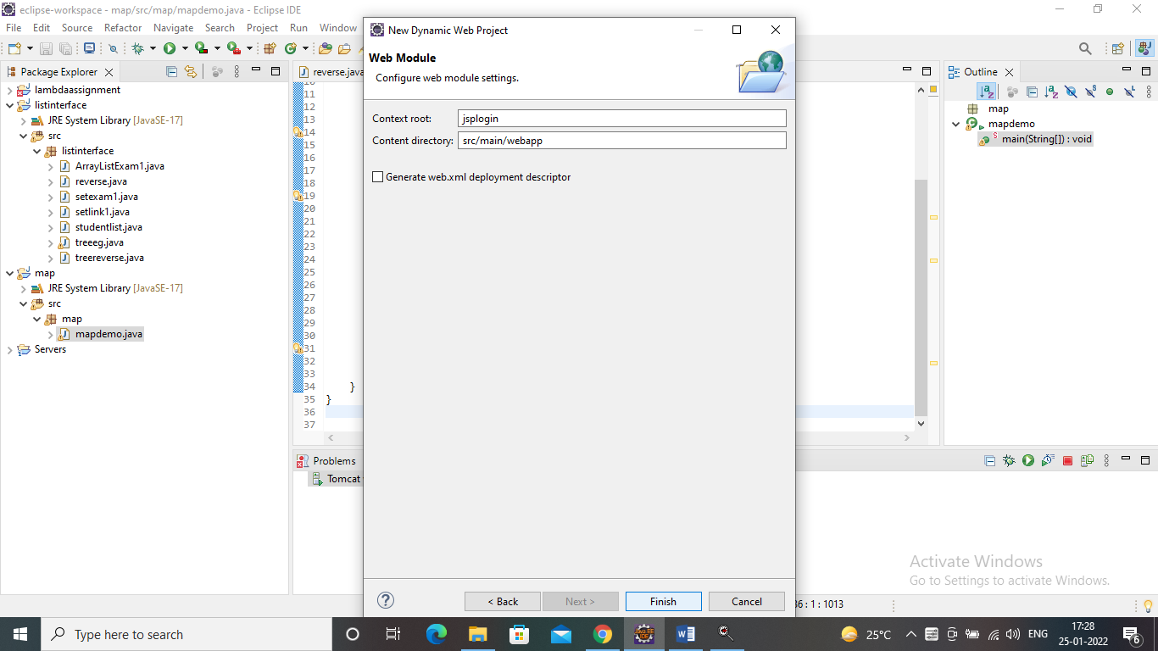

Step6:

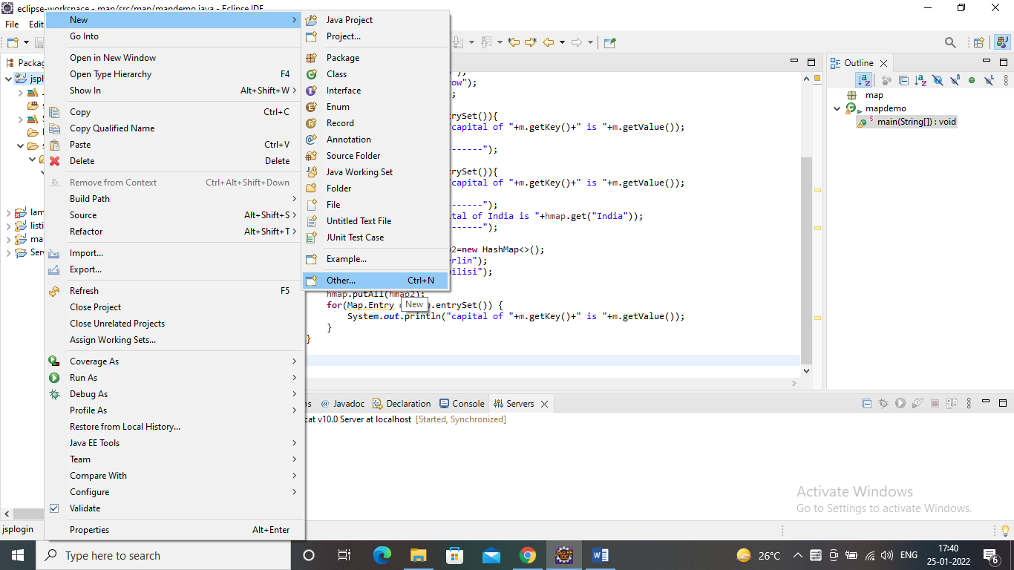

Step7:

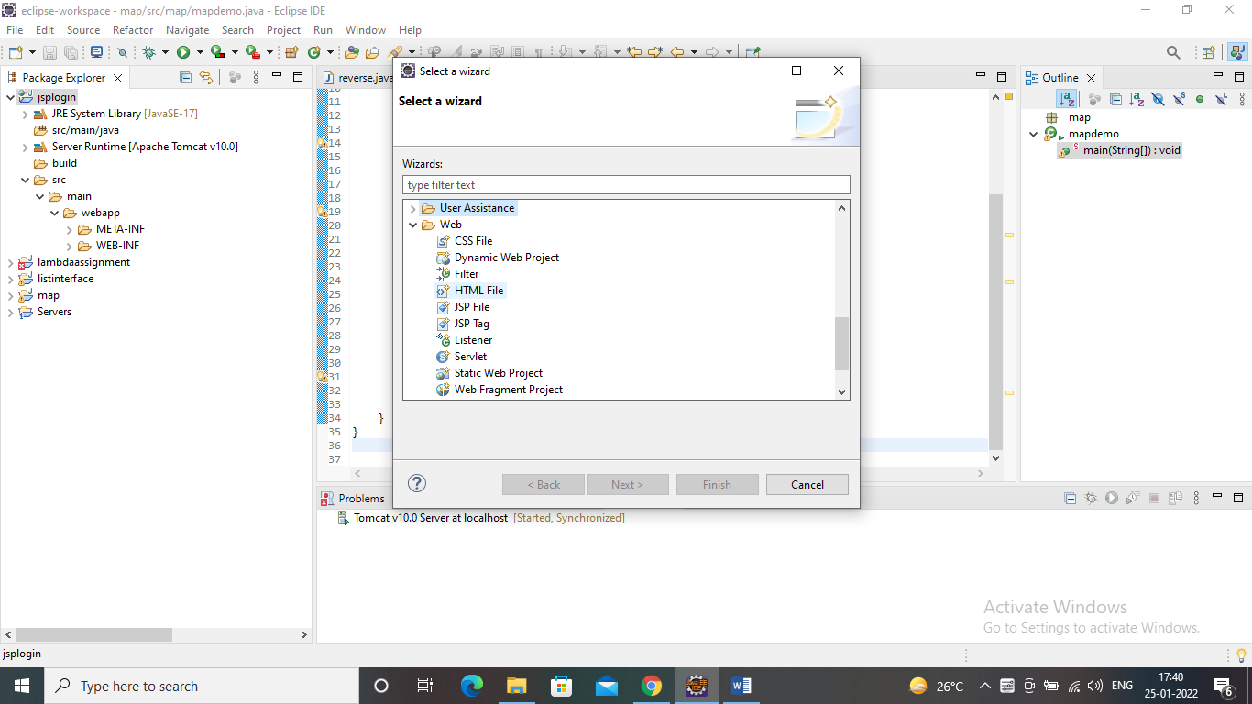

Step8:

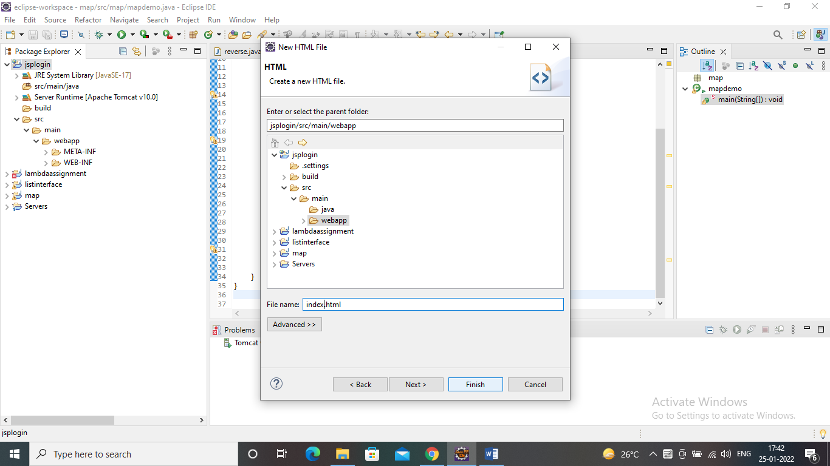

Step9:

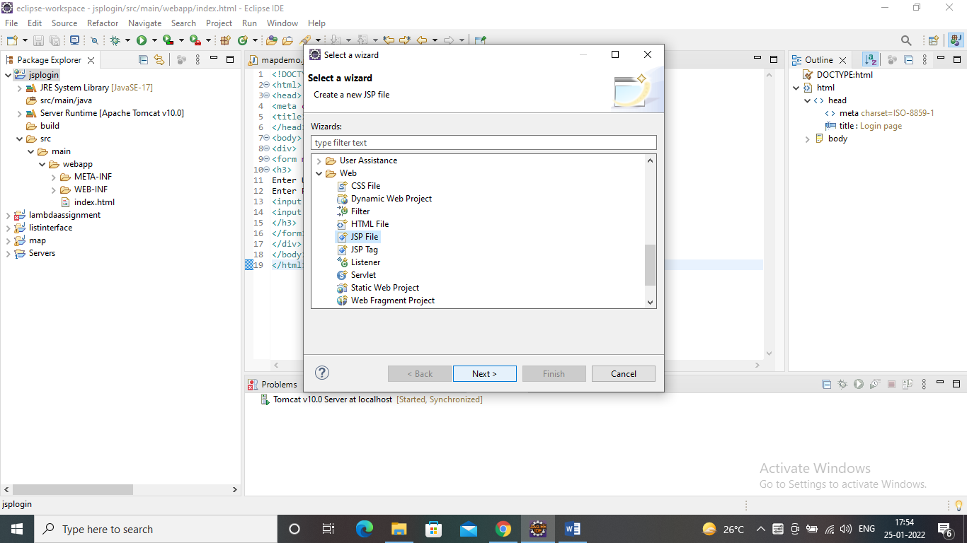

Step10:

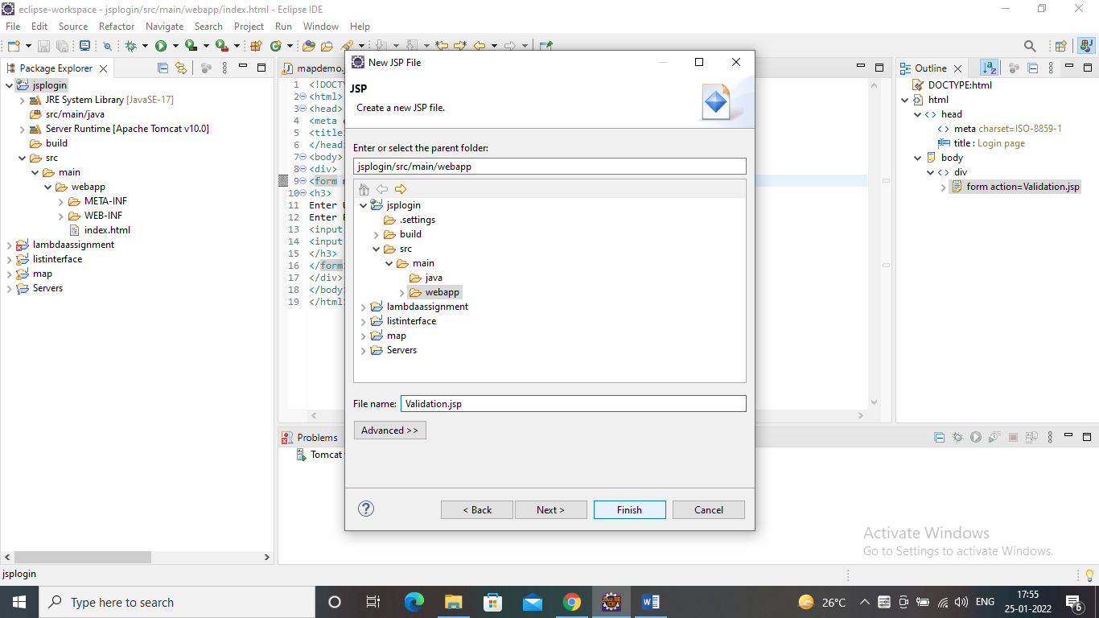

**Problem statement 1:** Create a Telephone directory using JSP and store all the information within a database, so that later could be retrieved as per the requirement. Make your own assumptions.

**Solution:**

create table if not exists telephone_directory (

id SERIAL primary key,

name varchar(64),

address varchar(128),

phone varchar(16)

);

insert into telephone_directory (name, address, phone) values

('Vasudha Arora', 'Seawoods', '+919820098732'),

('Snehal Kanojiya', 'Ghansoli', '+919820093122'),

('Himakshi Arora', 'Seawoods', '+919122444173'),

('Bharati Behra', 'Navi Mumbai', '+919812078732'),

('Chandrappa Chimmalgi', 'Panvel', '+919844028792');

select * from telephone_directory;

Add.jsp

<%@ page import="java.sql.*" %>

<%

try

{

String driver ="org.postgresql.Driver";

String url ="jdbc:postgresql://localhost:5432/postgres";

String username ="postgres";

String password ="password";

Connection con =null;

Class.forName(driver).newInstance();

con = DriverManager.getConnection(url,username,password);

System.out.println("Opened database successfully");

if(request.getParameter("btn_add")!=null) //check button click event not null

{

String phone,name, address;

address = request.getParameter("txt_address");

phone=request.getParameter("txt_phone");

name=request.getParameter("txt_name"); //txt_name

PreparedStatement pstmt=null; //create statement

pstmt=con.prepareStatement("insert into telephone_directory(name, address, phone)values(?,?,?)"); // insert query

pstmt.setString(1,name);

pstmt.setString(2,address);

pstmt.setString(3,phone);

pstmt.executeUpdate(); //execute query

con.close(); //close connection

out.println("Insert Successfully...! Click Back link.");// after insert record successfully message

}

}

catch(Exception e)

{

out.println(e);

}

%>

<html>

<head>

<title>Telephone Directory - Add</title>

<!-- javascript for form validation-->

<script>

function validate()

{

var address = document.myform.txt_address;

var phone = document.myform.txt_phone;

var name = document.myform.txt_name;

if (phone.value == "")

{

window.alert("please enter phone number ?");

phone.focus();

return false;

}

if (name.value == "")

{

window.alert("please enter name ?");

name.focus();

return false;

}

if (address.value == "") {

window.alert("Please enter address");

address.focus();

return false;

}

}

</script>

</head>

<body>

<form method="post" name="myform" onsubmit="return validate();">

<center>

<h1>Insert Record</h1>

</center>

<table>

<tr>

<td>Name</td>

<td><input type="text" name="txt_name"></td>

</tr>

<tr>

<td>Address</td>

<td><input type="text" name="txt_address"></td>

</tr>

<tr>

<td>Phone No</td>

<td><input type="text" name="txt_phone"></td>

</tr>

<tr>

<td><input type="submit" name="btn_add" value="Insert"></td>

</tr>

</table>

<center>

<h1><a href="index.jsp">Back</a></h1>

</center>

</form>

</body>

</html>

Index.jsp

<%@page import=*"java.sql.*"* %>

<%

try

{

String driver ="org.postgresql.Driver";

String url ="jdbc:postgresql://localhost:5432/postgres";

String username ="postgres";

String password ="password";

Connection con =null;

Class.forName(driver).newInstance();

con = DriverManager.getConnection(url,username,password);

System.out.println("Opened database successfully");

if(request.getParameter("delete")!=null)

{

int id=Integer.parseInt(request.getParameter("delete"));

PreparedStatement pstmt=null; //create statement

pstmt=con.prepareStatement("delete from telephone_directory where id=? "); // delete query

pstmt.setInt(1,id);

pstmt.executeUpdate(); //execute query

con.close(); //close connection

}

}

catch(Exception e)

{

out.println(e);

}

%>

<html>

<head>

<title>JSP:Insert, Update, Delete </title>

</head>

<body>

<center>

<h1><a href=*"add.jsp"*>Add Record</a></h1>

</center>

<table>

<tr>

<th>ID</th>

<th>Name</th>

<th>Address</th>

<th>Phone No</th>

<th>Update</th>

<th>Delete</th>

</tr>

<%

try

{

String driver ="org.postgresql.Driver";

String url ="jdbc:postgresql://localhost:5432/postgres";

String username ="postgres";

String password ="password";

Connection con =null;

Class.forName(driver).newInstance();

con = DriverManager.getConnection(url,username,password);

PreparedStatement pstmt=null; //create statement

pstmt=con.prepareStatement("select * from telephone_directory"); //select query

ResultSet rs=pstmt.executeQuery(); //execute query and set in resultset object rs.

while(rs.next())

{

%>

<tr>

<td><%=rs.getInt(1)%></td>

<td><%=rs.getString(2)%></td>

<td><%=rs.getString(3)%></td>

<td><%=rs.getString(4) %> </td>

<td><a href=*"update.jsp?edit=*<%=rs.getInt(1)%>*"*>Edit</a></td>

<td><a href=*"?delete=*<%=rs.getInt(1)%>*"*>Delete</a></td>

</tr>

<%

}

}

catch(Exception e)

{

out.println(e);

}

%>

</table>

</body>

</html>

Update.jsp

<%@ page import=*"java.sql.*"* %>

<%

try

{

String driver ="org.postgresql.Driver";

String url ="jdbc:postgresql://localhost:5432/postgres";

String username ="postgres";

String password ="password";

Connection con =null;

Class.forName(driver).newInstance();

con = DriverManager.getConnection(url,username,password);

System.out.println("Opened database successfully");

if(request.getParameter("btn_update")!=null) //check button click event not null

{

int hide;//,rno,name,semester,course;

String phone,name, address;

hide=Integer.parseInt(request.getParameter("txt_hide")); //it is hidden id get for update record

address = request.getParameter("txt_address");

phone=request.getParameter("txt_phone");

name=request.getParameter("txt_name"); //txt_name

address = request.getParameter("txt_address");

phone=request.getParameter("txt_phone");

name=request.getParameter("txt_name"); //txt_name

System.out.println(hide);

System.out.println(name);

System.out.println(address);

System.out.println(phone);

PreparedStatement pstmt=null; //create statement

pstmt=con.prepareStatement("update telephone_directory set name=?, address=?, phone=? where id=?"); // update query

pstmt.setString(1,name);

pstmt.setString(2,address);

pstmt.setString(3,phone);

pstmt.setInt(4,hide);

pstmt.executeUpdate(); //execute query

con.close(); //connection close

out.println("Update Successfully...! Click Back link."); //after update record successfully message

}

}

catch(Exception e)

{

out.println(e);

}

%>

<html>

<head>

<title>JSP:Insert, Update, Delete using MySQL</title>

<!-- javascript for form validation-->

<script>

function validate()

{

var address = document.myform.txt_address;

var phone = document.myform.txt_phone;

var name = document.myform.txt_name;

if (phone.value == "")

{

window.alert("please enter phone number ?");

phone.focus();

return false;

}

if (name.value == "")

{

window.alert("please enter name ?");

name.focus();

return false;

}

if (address.value == "") {

window.alert("Please enter address");

address.focus();

return false;

}

}

</script>

</head>

<body>

<form method=*"post"* name=*"myform"* onsubmit="return validate();">

<center>

<h1>Update Record</h1>

</center>

<table>

<%

try

{

String driver ="org.postgresql.Driver";

String url ="jdbc:postgresql://localhost:5432/postgres";

String username ="postgres";

String password ="password";

Connection con =null;

Class.forName(driver).newInstance();

con = DriverManager.getConnection(url,username,password);

System.out.println("Opened database successfully");

if(request.getParameter("edit")!=null)

{

int id=Integer.parseInt(request.getParameter("edit"));

String phone,name, address;

PreparedStatement pstmt=null; // create statement

pstmt=con.prepareStatement("select * from telephone_directory where id=?");

// sql select query

pstmt.setInt(1,id);

ResultSet rs=pstmt.executeQuery(); // execute query store in resultset object rs.

while(rs.next())

{

id=rs.getInt(1);

name=rs.getString(2);

address=rs.getString(3);

phone=rs.getString(4);

%>

<tr>

<td>Name</td>

<td><input type=*"text"* name=*"txt_name"* value=*"*<%=name%>*"*></td>

</tr>

<tr>

<td>Address</td>

<td><input type=*"text"* name=*"txt_address"* value=*"*<%=address%>*"*></td>

</tr>

<tr>

<td>Phone</td>

<td><input type=*"text"* name=*"txt_phone"* value=*"*<%=phone%>*"*></td>

</tr>

<tr>

<td><input type=*"submit"* name=*"btn_update"* value=*"Update"*></td>

</tr>

<input type=*"hidden"* name=*"txt_hide"* value=*"*<%=id%>*"*>

<%

}

}

}

catch(Exception e)

{

out.println(e);

}

%>

</table>

<center>

<h1><a href=*"index.jsp"*>Back</a></h1>

</center>

</form>

</body>

</html>

**Output:**

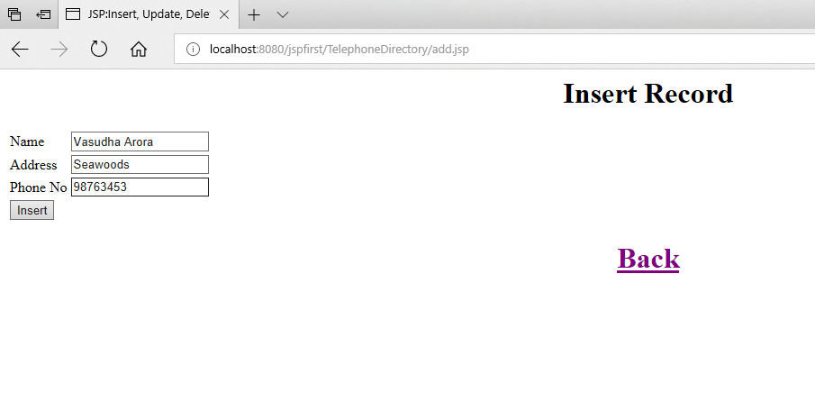

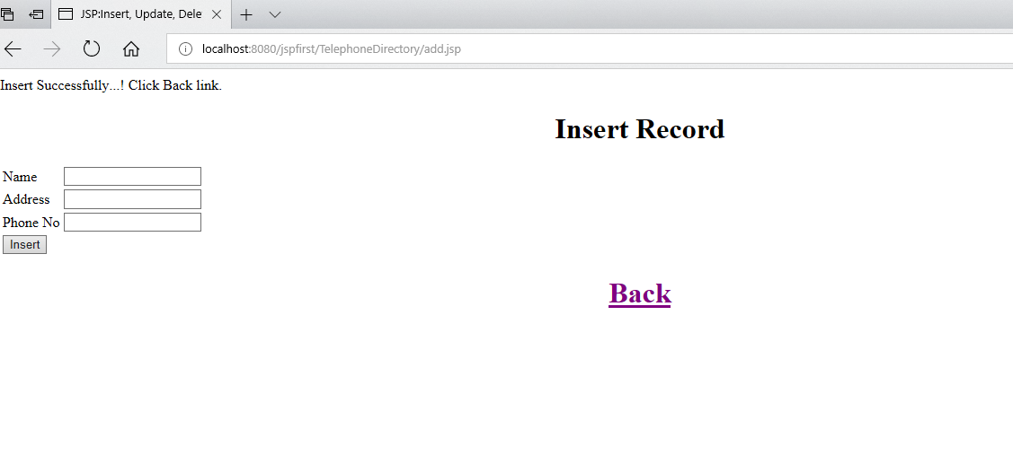

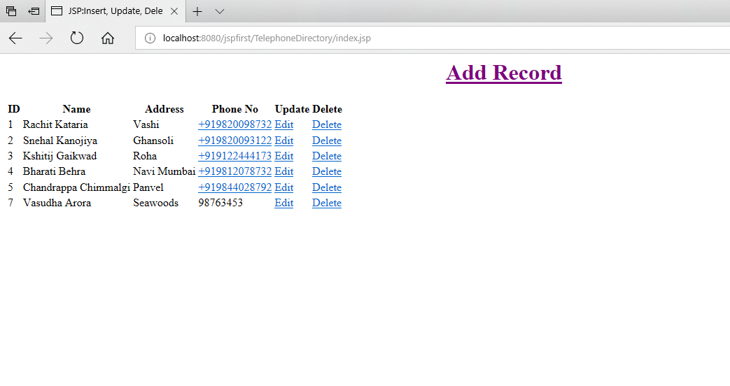

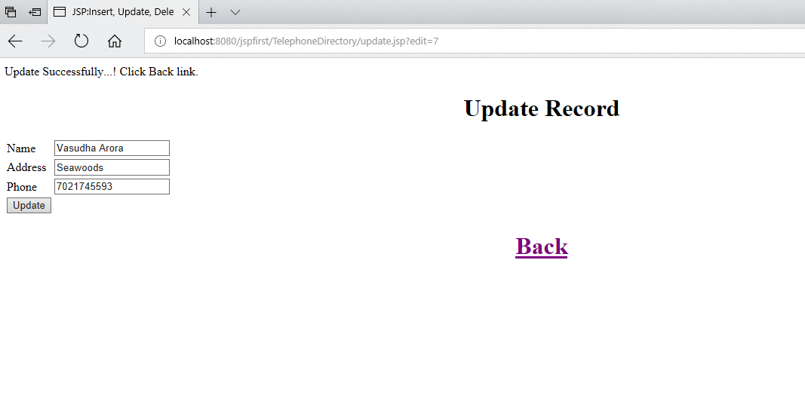

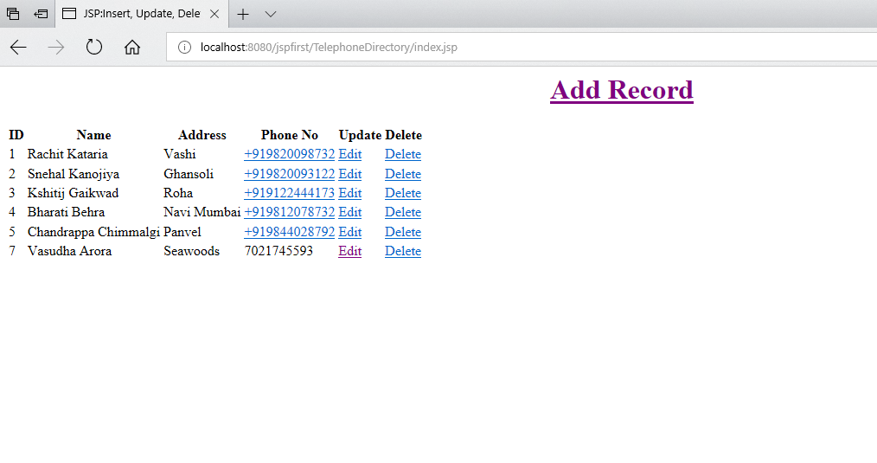

If you click on delete link then one record will get deleted as shown below.

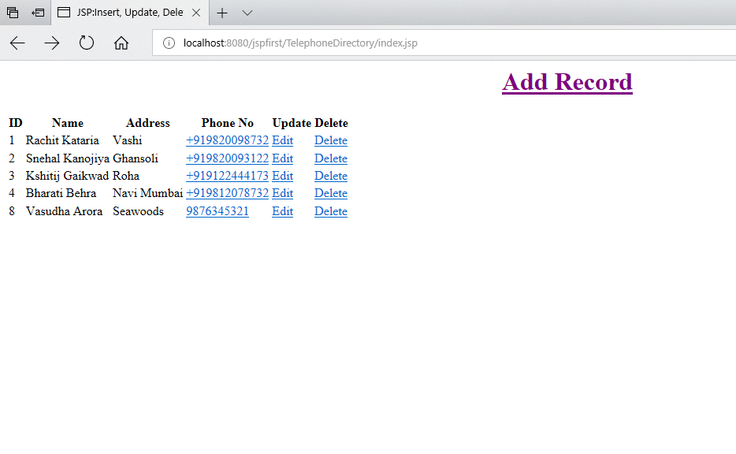

**Problem statement 2:**  Write a JSP page to display the Registration form (Make your own assumptions)

**Solution:**

Reg.jsp

<%@ page language=*"java"* contentType=*"text/html; charset=ISO-8859-1"*

pageEncoding=*"ISO-8859-1"*%>

<!DOCTYPE html>

<html>

<head>

<meta charset=*"ISO-8859-1"*>

<title>Registratin Form</title>

</head>

<body>

<form action=*"register.jsp"* method=*"post"*>

<table style="with: *50%*">

<tr>

<td>First Name</td>

<td><input type=*"text"* name=*"first_name"* /></td>

</tr>

<tr>

<td>Last Name</td>

<td><input type=*"text"* name=*"last_name"* /></td>

</tr>

<tr>

<td>UserName</td>

<td><input type=*"text"* name=*"username"* /></td>

</tr>

<tr>

<td>Password</td>

<td><input type=*"password"* name=*"password"* /></td>

</tr>

<tr>

<td>confirm Password</td>

<td><input type=*"password"* name=*"cpassword"* /></td>

</tr>

<tr>

<td>Address</td>

<td><input type=*"text"* name=*"address"* /></td>

</tr>

<tr>

<td>Contact No</td>

<td><input type=*"text"* name=*"contact"* /></td>

</tr></table>

<input type=*"submit"* value=*"Submit"* /></form>

</body>

</html>

Register.jsp

<%@ page language=*"java"* contentType=*"text/html; charset=ISO-8859-1"*

pageEncoding=*"ISO-8859-1"*%>

<!DOCTYPE html>

<html>

<head>

<meta charset=*"ISO-8859-1"*>

<title>welcome</title>

</head>

<body>

<%

String n=request.getParameter("username");

String str1=request.getParameter("password");

String str2=request.getParameter("cpassword");

if(str1.equals(str2))

{

out.println("<h3>Welcome your account is created</h3>"+n);

}

else

{

out.println("<h3>Sorry, your password is mismatched</h3>");

}

%>

</body>

</html>

**Output:**

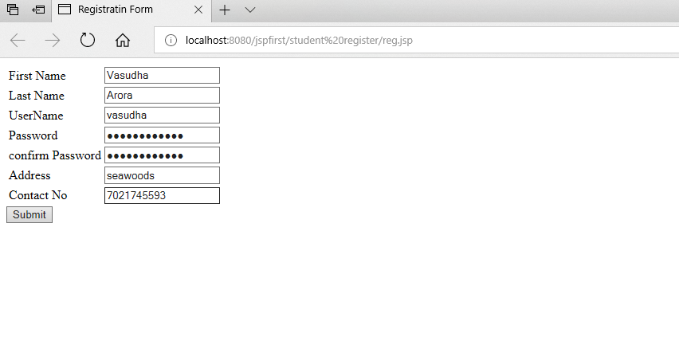

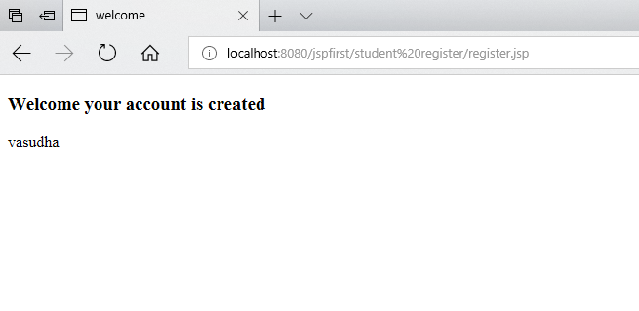

**Problem statement 3:** Write a JSP program to add, delete and display the records from StudentMaster (RollNo, Name, Semester, Course) table.

**Solution:**

CREATE TABLE if not exists student (

id SERIAL PRIMARY KEY,

rno varchar(32),

name varchar(64),

semester varchar(32),

course varchar(128)

);

insert into student (rno, name, semester, course) values

('B24', 'Vasudha Arora', 'SEM I', 'Masters of Computer Application'),

('B01', 'Rohan Alate', 'SEM I', 'Masters of Computer Application'),

('B22', 'Snehal Kanojiya', 'SEM I', 'Masters of Computer Application'),

('B07', 'Bharati Behra', 'SEM I', 'Masters of Computer Application'),

('B20', 'Tejashree Jain', 'SEM I', 'Masters of Computer Application'),

('B68', 'Sajin Salimkumar', 'SEM I', 'Masters of Computer Application');

select * from student;

Add.jsp

<%@ page import=*"java.sql.*"* %>

<%

try

{

String driver ="org.postgresql.Driver";

String url ="jdbc:postgresql://localhost:5432/postgres";

String username ="postgres";

String password ="password";

Connection con =null;

Class.forName(driver).newInstance();

con = DriverManager.getConnection(url,username,password);

System.out.println("Opened database successfully");

if(request.getParameter("btn_add")!=null) //check button click event not null

{

String rno,name,semester,course;

rno=request.getParameter("txt_rno");

name=request.getParameter("txt_name"); //txt_name

semester=request.getParameter("txt_sem"); //txt_owner

course=request.getParameter("txt_course"); //txt_owner

PreparedStatement pstmt=null; //create statement

pstmt=con.prepareStatement("insert into student(rno,name,semester,course)values(?,?,?,?)"); // insert query

pstmt.setString(1,rno);

pstmt.setString(2,name);

pstmt.setString(3,semester);

pstmt.setString(4,course);

pstmt.executeUpdate(); //execute query

con.close(); //close connection

out.println("Insert Successfully...! Click Back link.");// after insert record successfully message

}

}

catch(Exception e)

{

out.println(e);

}

%>

<html>

<head>

<title>JSP:Insert, Update, Delete using MySQL</title>

<!-- javascript for form validation-->

<script>

function validate()

{

var rno = document.myform.txt_rno;

var name = document.myform.txt_name;

var semester = document.myform.txt_sem;

var course = document.myform.txt_course;

if (rno.value == "")

{

window.alert("please enter rno ?");

name.focus();

return false;

}

if (name.value == "")

{

window.alert("please enter name ?");

name.focus();

return false;

}

if (semester.value == "")

{

window.alert("please enter sem ?");

owner.focus();

return false;

}

if (course.value == "")

{

window.alert("please enter course ?");

owner.focus();

return false;

}

}

</script>

</head>

<body>

<form method=*"post"* name=*"myform"* onsubmit="return validate();">

<center>

<h1>Insert Record</h1>

</center>

<table>

<tr>

<td>Roll No</td>

<td><input type=*"text"* name=*"txt_rno"*></td>

</tr>

<tr>

<td>Name</td>

<td><input type=*"text"* name=*"txt_name"*></td>

</tr>

<tr>

<td>Sem</td>

<td><input type=*"text"* name=*"txt_sem"*></td>

</tr>

<tr>

<td>Course</td>

<td><input type=*"text"* name=*"txt_course"*></td>

</tr>

<tr>

<td><input type=*"submit"* name=*"btn_add"*

value=*"Insert"*></td>

</tr>

</table>

<center>

<h1><a href=*"index.jsp"*>Back</a></h1>

</center>

</form>

</body>

</html>

Index.jsp

<%@ page import=*"java.sql.*"* %>

<%

try

{

String driver ="org.postgresql.Driver";

String url ="jdbc:postgresql://localhost:5432/postgres";

String username ="postgres";

String password ="password";

Connection con =null;

Class.forName(driver).newInstance();

con = DriverManager.getConnection(url,username,password);

System.out.println("Opened database successfully");

if(request.getParameter("delete")!=null)

{

int id=Integer.parseInt(request.getParameter("delete"));

PreparedStatement pstmt=null; //create statement

pstmt=con.prepareStatement("delete from student where id=? "); // delete query

pstmt.setInt(1,id);

pstmt.executeUpdate(); //execute query

con.close(); //close connection

}

}

catch(Exception e)

{

out.println(e);

}

%>

<html>

<head>

<title>JSP:Insert, Update, Delete </title>

</head>

<body>

<center>

<h1><a href=*"add.jsp"*>Add Record</a></h1>

</center>

<table>

<tr>

<th>ID</th>

<th>Roll No</th>

<th>Name</th>

<th>Sem</th>

<th>Course</th>

<th>Update</th>

<th>Delete</th>

</tr>

<%

try

{

String driver ="org.postgresql.Driver";

String url ="jdbc:postgresql://localhost:5432/postgres";

String username ="postgres";

String password ="password";

Connection con =null;

Class.forName(driver).newInstance();

con = DriverManager.getConnection(url,username,password);

PreparedStatement pstmt=null; //create statement

pstmt=con.prepareStatement("select * from student"); //select query

ResultSet rs=pstmt.executeQuery(); //execute query and set in resultset object rs.

while(rs.next())

{

%>

<tr>

<td><%=rs.getInt(1)%></td>

<td><%=rs.getString(2)%></td>

<td><%=rs.getString(3)%></td>

<td><%=rs.getString(4)%></td>

<td><%=rs.getString(5)%></td>

<td><a href=*"update.jsp?edit=*<%=rs.getInt(1)%>*"*>Edit</a></td>

<td><a href=*"?delete=*<%=rs.getInt(1)%>*"*>Delete</a></td>

</tr>

<%

}

}

catch(Exception e)

{

out.println(e);

}

%>

</table>

</body>

</html>

Update.jsp

<%@ page import=*"java.sql.*"* %>

<%

try

{

String driver ="org.postgresql.Driver";

String url ="jdbc:postgresql://localhost:5432/postgres";

String username ="postgres";

String password ="password";

Connection con =null;

Class.forName(driver).newInstance();

con = DriverManager.getConnection(url,username,password);

System.out.println("Opened database successfully");

if(request.getParameter("btn_update")!=null) //check button click event not null

{

int hide,rno,name,semester,course;;

String rno_up,name_up,semester_up,course_up;

hide=Integer.parseInt(request.getParameter("txt_hide")); //it is hidden id get for update record

rno_up=request.getParameter("txt_rno");

name_up=request.getParameter("txt_name"); //txt_name

semester_up=request.getParameter("txt_semester");

course_up=request.getParameter("txt_course");

PreparedStatement pstmt=null; //create statement

pstmt=con.prepareStatement("update student set rno=?,name=?, semester=?, course=? where id=?"); // update query

pstmt.setString(1,rno_up);

pstmt.setString(2,name_up);

pstmt.setString(3,semester_up);

pstmt.setString(4,course_up);

pstmt.setInt(5,hide);

pstmt.executeUpdate(); //execute query

con.close(); //connection close

out.println("Update Successfully...! Click Back link."); //after update record successfully message

}

}

catch(Exception e)

{

out.println(e);

}

%>

<html>

<head>

<title>JSP:Insert, Update, Delete using MySQL</title>

<!-- javascript for form validation-->

<script>

function validate()

{

var rno = document.myform.txt_rno;

var name = document.myform.txt_name;

var semester = document.myform.txt_semester;

var course = document.myform.txt_course;

if (rno.value == "")

{

window.alert("please enter rno ?");

name.focus();

return false;

}

if (name.value == "")

{

window.alert("please enter name ?");

name.focus();

return false;

}

if (semester.value == "")

{

window.alert("please enter sem ?");

owner.focus();

return false;

}

if (course.value == "")

{

window.alert("please enter course ?");

owner.focus();

return false;

}

}

</script>

</head>

<body>

<form method=*"post"* name=*"myform"* onsubmit="return validate();">

<center>

<h1>Update Record</h1>

</center>

<table>

<%

try

{

String driver ="org.postgresql.Driver";

String url ="jdbc:postgresql://localhost:5432/postgres";

String username ="postgres";

String password ="password";

Connection con =null;

Class.forName(driver).newInstance();

con = DriverManager.getConnection(url,username,password);

System.out.println("Opened database successfully");

if(request.getParameter("edit")!=null)

{

int id=Integer.parseInt(request.getParameter("edit"));

String rno,name,semester,course;

PreparedStatement pstmt=null; // create statement

pstmt=con.prepareStatement("select * from student where id=?");

// sql select query

pstmt.setInt(1,id);

ResultSet rs=pstmt.executeQuery(); // execute query store in resultset object rs.

while(rs.next())

{

id=rs.getInt(1);

rno=rs.getString(2);

name=rs.getString(3);

semester=rs.getString(4);

course=rs.getString(5);

%>

<tr>

<td>Roll NO</td>

<td><input type=*"text"* name=*"txt_rno"* value=*"*<%=rno%>*"*></td>

</tr>

<tr>

<td>Name</td>

<td><input type=*"text"* name=*"txt_name"*

value=*"*<%=name%>*"*></td>

</tr>

<tr>

<td>Sem</td>

<td><input type=*"text"* name=*"txt_semester"*

value=*"*<%=semester%>*"*></td>

</tr>

<tr>

<td>Course</td>

<td><input type=*"text"* name=*"txt_course"*

value=*"*<%=course%>*"*></td>

</tr>

<tr>

<td><input type=*"submit"* name=*"btn_update"*

value=*"Update"*></td>

</tr>

<input type=*"hidden"* name=*"txt_hide"* value=*"*<%=id%>*"*>

<%

}

}

}

catch(Exception e)

{

out.println(e);

}

%>

</table>

<center>

<h1><a href=*"index.jsp"*>Back</a></h1>

</center>

</form>

</body>

</html>

**Output:**

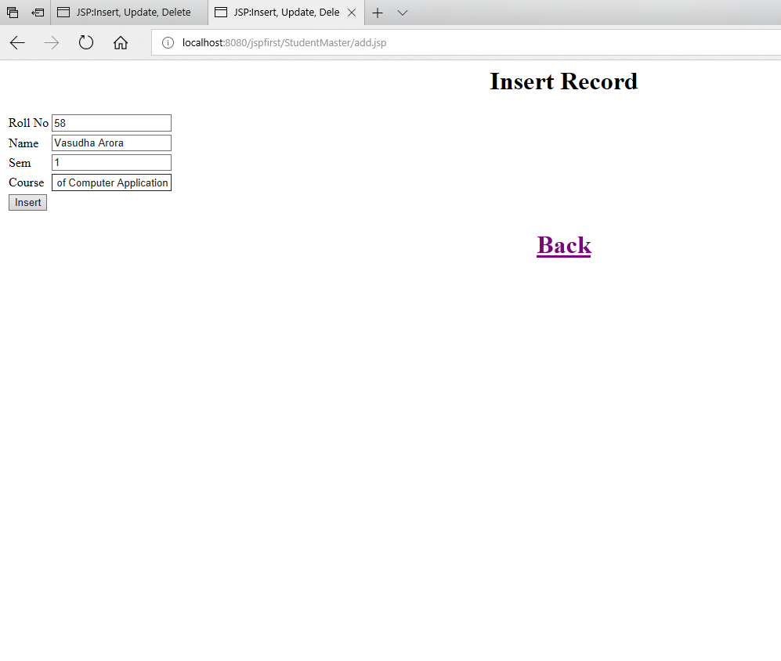

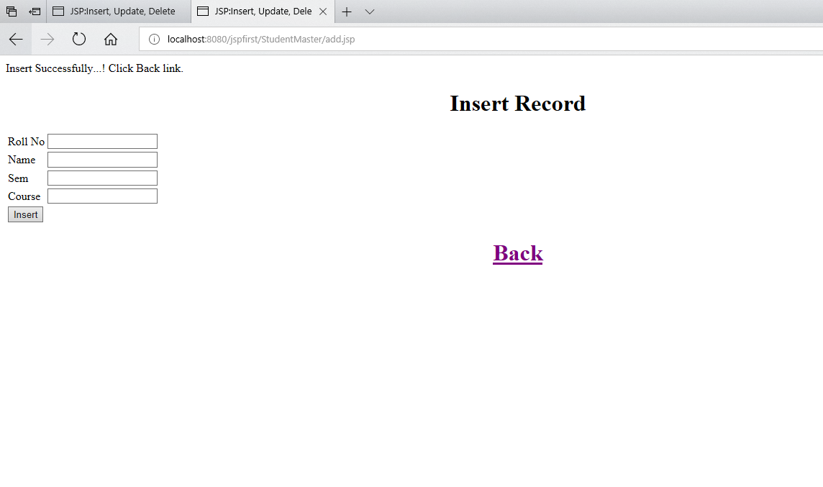

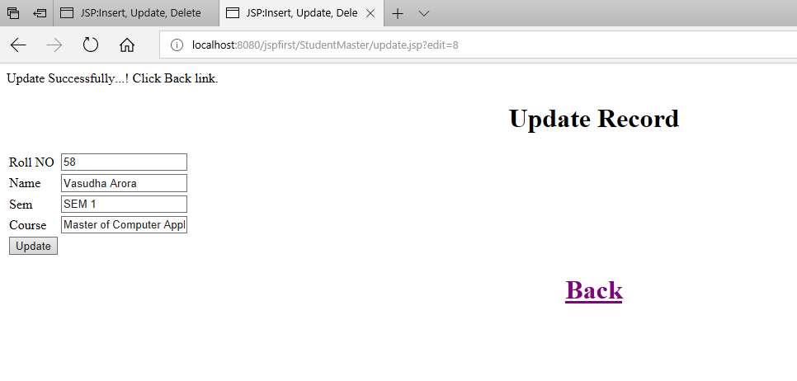

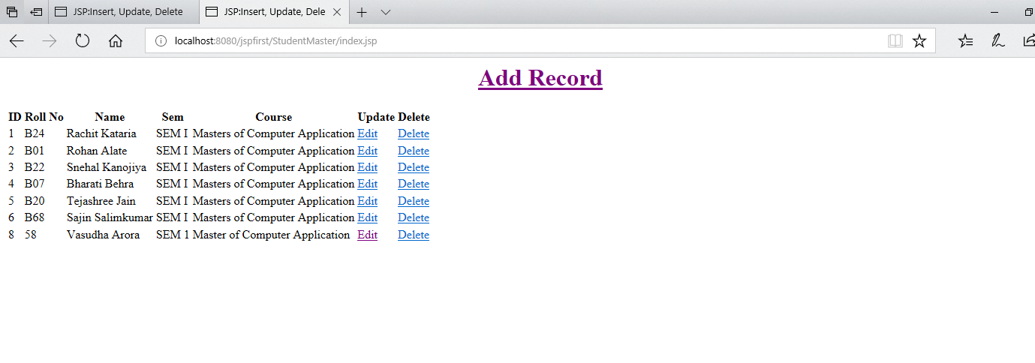

**Problem statement 4:**  Design loan calculator using JSP which accepts Period of Time (in years) and Principal Loan Amount. Display the payment amount for each loan and then list the loan balance and interest paid for each payment over the term of the loan for the following time period and interest rate:  
a. 1 to 7 year at 5.35%  
b. 8 to 15 year at 5.5%  
c. 16 to 30 year at 5.75%

**Solution:**

Calculate.jsp

<%@ page language="java" contentType="text/html; charset=ISO-8859-1"

pageEncoding="ISO-8859-1"%>

<!DOCTYPE html>

<html>

<head>

<meta charset="ISO-8859-1">

<title>Loan Calculator | Results</title>

<style>

body {

background-color: #EEEEEE;

}

table.LoanCalculator {

background-color: #ffffff;

border-collapse: collapse;

border-width: 2px;

border-color: #0078d7;

border-style: solid;

color: #000000;

}

table.LoanCalculator td, table.LoanCalculator th {

text-align: center;

border-width: 2px;

border-color: #0078d7;

border-style: solid;

padding: 3px;

}

table.LoanCalculator th {

color: #ffffff;

}

table.LoanCalculator thead {

background-color: #0078d7;

}

.container {

display: grid;

}

.left-half {

grid-column: 1;

}

.right-half {

grid-column: 2;

display: flex;

justify-content: center;

}

</style>

</head>

<body>

<div class="container">

<div class="left-half">

<h1>Loan Calculator Results</h1>

<%

double pAmt = Double.parseDouble(request.getParameter("pAmt"));

int durationInYears = Integer.parseInt(request.getParameter("loanPeriod"));

int durationInMonths = durationInYears * 12;

double rateOfInterest = 0;

if(durationInYears <= 7 ){

rateOfInterest = 5.35;

}else if(durationInYears > 7 && durationInYears <= 15){

rateOfInterest = 5.5;

}else {

rateOfInterest = 5.75;

}

double montlyInterest = rateOfInterest / 100 / 12;

double tempCal = Math.pow( 1 + montlyInterest, durationInMonths),

monthlyPayment = (pAmt * tempCal * montlyInterest) / (tempCal - 1),

totalAmount = monthlyPayment * durationInMonths,

totalInterest = (monthlyPayment * durationInMonths) - pAmt;

double interestPerPayment = monthlyPayment - (pAmt/durationInMonths),

amountFromBalance = monthlyPayment - interestPerPayment,

paidInterest = 0,

paidAmount= 0,

remainingBalance = pAmt;

out.println("<h3>Monthly Payment: " + Math.round(monthlyPayment) + "</h3>");

out.println("<h3>Total amount: " + Math.round(totalAmount) + "</h3>");

out.println("<h3>Total interest: " + Math.round(totalInterest) + "</h3>");

%>

</div>

<div class="right-half">

<table class="LoanCalculator">

<thead>

<tr><th style="font-size: 32px;" colspan="5">Payment Breakdown</th></tr>

<tr>

<th>Month</th>

<th>Interest Paid</th>

<th>Amount Paid</th>

<th>Remaining Amount</th>

<th>Interest Rate</th>

</tr>

</thead>

<tbody>

<%

for(int month = 1; month <= durationInMonths; month++){

paidInterest += interestPerPayment;

paidAmount += amountFromBalance;

remainingBalance -= amountFromBalance;

out.println("<tr>");

out.println("<td>" + month + "</td>");

out.println("<td>" + Math.round(paidInterest) + "</td>");

out.println("<td>" + Math.round(paidAmount) + "</td>");

out.println("<td>" + Math.round(remainingBalance) +"</td>");

out.println("<td>" + rateOfInterest +"</td>");

out.println("</tr>");

}

%>

</tbody>

</table>

</div>

</div>

</body>

</html>

cnew.jsp

<%@ page language="java" contentType="text/html; charset=ISO-8859-1"

pageEncoding="ISO-8859-1"%>

<!DOCTYPE html>

<html>

<head>

<meta charset="ISO-8859-1">

<title>Loan Calculator | Results</title>

<style>

table.GeneratedTable {

width: 25%;

background-color: #ffffff;

border-collapse: collapse;

border-width: 2px;

border-color: #ffcc00;

border-style: solid;

color: #000000;

}

table.GeneratedTable td, table.GeneratedTable th {

border-width: 2px;

border-color: #ffcc00;

border-style: solid;

padding: 3px;

}

table.GeneratedTable thead {

background-color: #ffcc00;

}

</style>

</head>

<body>

<h1>Loan Calculator Results</h1>

<%

double pAmt = Double.parseDouble(request.getParameter("pAmt"));

int durationInYears = Integer.parseInt(request.getParameter("loanPeriod"));

int durationInMonths = durationInYears * 12;

double rateOfInterest = 0;

double p = pAmt; double r; double t = durationInYears;

if(durationInYears <= 7 ){

rateOfInterest = 5.35;

}else if(durationInYears > 7 && durationInYears <= 15){

rateOfInterest = 5.5;

}else {

rateOfInterest = 5.75;

}

double montlyInterest = rateOfInterest / 100 / 12;

double tempCal = Math.pow( 1 + montlyInterest, durationInMonths),

monthlyPayment = (pAmt * tempCal * montlyInterest) / (tempCal -1),

totalAmount = monthlyPayment * durationInMonths,

totalInterest = (monthlyPayment * durationInMonths) - pAmt;

double interestPerPayment = monthlyPayment - (pAmt/durationInMonths),

amountFromBalance = monthlyPayment - interestPerPayment,

paidInterest = 0,

paidAmount= 0,

remainingBalance = pAmt;

out.println("<h3>Monthly Payment: " + Math.round(monthlyPayment) + "</h3>");

out.println("<h3>Total amount: " + Math.round(totalAmount) + "</h3>");

out.println("<h3>Total interest: " + Math.round(totalInterest) + "</h3>");

%>

<table class="GeneratedTable">

<thead>

<tr>

<th>Year</th>

<th>Interest Paid</th>

<th>Amount Paid</th>

<th>Remaining Amount</th>

<th>Interest Rate</th>

</tr>

</thead>

<tbody>

<%

for(int month = 1; month <= durationInMonths; month++){

paidInterest += interestPerPayment;

paidAmount += amountFromBalance;

remainingBalance -= amountFromBalance;

if(month % 12 == 0){

out.println("<tr>");

out.println("<td>" + Math.round(month/12) + "</td>");

out.println("<td>" + Math.round(paidInterest) + "</td>");

out.println("<td>" + Math.round(paidAmount) + "</td>");

out.println("<td>" + Math.round(remainingBalance) +"</td>");

out.println("<td>" + rateOfInterest +"</td>");

out.println("</tr>");

}

}

%>

</tbody>

</table>

</body>

</html>

index.jsp

<!DOCTYPE html>

<html>

<head>

<meta charset="ISO-8859-1">

<title>Loan Calculator</title>

<style>

form {

display: flex;

flex-direction: column;

width: 25%;

}

</style>

</head>

<body>

<form method="POST" action="calculate.jsp">

<label for="pAmt">Principal Amount</label>

<input name="pAmt" type="text"><br>

<label for="loanPeriod">Loan Period (In Years)</label>

<input name="loanPeriod" type="text"><br>

<input type="Submit" style="width: 40%;" name="Submit" value="Submit"/>

</form>

</body>

</html>

test.jsp

<%@ page language="java" contentType="text/html; charset=ISO-8859-1"

pageEncoding="ISO-8859-1"%>

<!DOCTYPE html>

<html>

<head>

<meta charset="ISO-8859-1">

<title>Loan Calculator | Results</title>

<style>

table.GeneratedTable {

width: 25%;

background-color: #ffffff;

border-collapse: collapse;

border-width: 2px;

border-color: #ffcc00;

border-style: solid;

color: #000000;

}

table.GeneratedTable td, table.GeneratedTable th {

border-width: 2px;

border-color: #ffcc00;

border-style: solid;

padding: 3px;

}

table.GeneratedTable thead {

background-color: #ffcc00;

}

</style>

</head>

<body>

<h1>Loan Calculator Results</h1>

<%

double pAmt = Double.parseDouble(request.getParameter("pAmt"));

int durationInYears = Integer.parseInt(request.getParameter("loanPeriod"));

int durationInMonths = durationInYears * 12;

double rateOfInterest = 0;

double totalAmount = 0;

double interestPaid = 0;

double p = pAmt; double r; double t = durationInYears;

if(durationInYears <= 7 ){

rateOfInterest = 5.35;

}else if(durationInYears > 7 && durationInYears <= 15){

rateOfInterest = 5.5;

}else {

rateOfInterest = 5.75;

}

double emi;

r = rateOfInterest;

r = r / (12 * 100); // one month interest

t = t * 12; // one month period

emi = (p * r * (float)Math.pow(1 + r, t))

/ (float)(Math.pow(1 + r, t) - 1);

out.print("<h1>EMI: " + emi + "</h1>");

out.println("<h3>Total Interest Amount: " + Double.toString((emi*durationInMonths)/rateOfInterest) + "</h3>");

out.println("<h3>Total Loan Amount: " + Double.toString(emi * durationInMonths) + "</h3>");

%>

<table class="GeneratedTable">

<thead>

<tr>

<th>Month</th>

<th>Interest Paid</th>

<th>Amount Paid</th>

<th>Remaining Amount</th>

<th>Interest Rate</th>

</tr>

</thead>

<tbody>

<%

for(int year = 1; year <= durationInYears; year++){

//interestPaid += rateOfInterest * durationInMonths;

if(year <= 7 ){

rateOfInterest = 5.35;

}else if(year > 7 && year <= 15){

rateOfInterest = 5.5;

}else {

rateOfInterest = 5.75;

}

out.println("<tr>");

out.println("<td>" + year + "</td>");

out.println("<td>" + (emi*12/rateOfInterest)*year + "</td>");

out.println("<td>" + (year * 12 * emi)+ "</td>");

out.println("<td>"+ ((emi * durationInMonths) - (emi * year * 12)) +"</td>");

out.println("<td>"+ rateOfInterest +"</td>");

out.println("</tr>");

}

%>

</tbody>

</table>

</body>

</html>

**Output:**

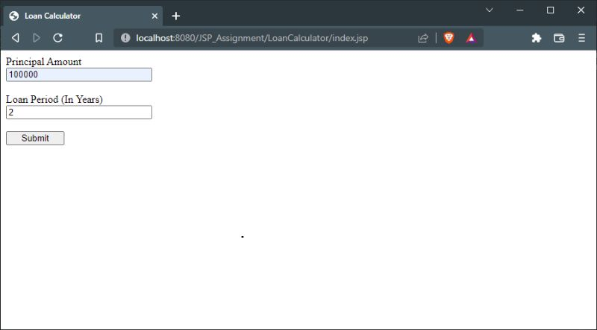

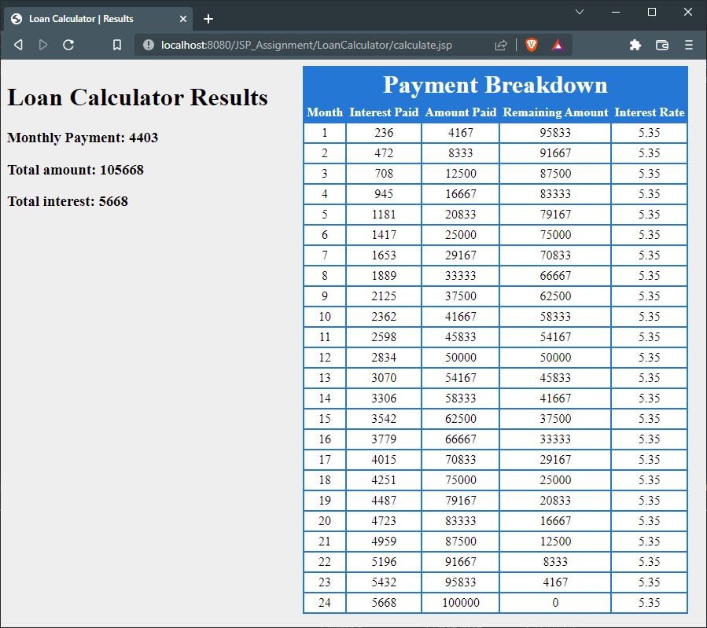

**Problem statement 5:** Write a program using JSP that displays a webpage consisting Application form for change of Study Center which can be filled by any student who wants to change his/ her study center. Make necessary assumptions.

**Solution:**

index.jsp

<%@ page import="java.sql.*" %>

<html>

<head>

<title>Study Center Updation Form - Index</title>

</head>

<body>

<h1>Update Study Center Form</h1>

<form action="update.jsp" method="post">

<table style="width: 50%">

<tr>

<td>Roll No.</td>

<td><input type="text" name="txt_rno" /></td>

</tr>

<tr>

<td>Name</td>

<td><input type="text" name="txt_name" /></td>

</tr>

<tr>

<td>Study Center</td>

<td>

<select name="study_center">

<option value="Vashi">Vashi</option>

<option value="Kharghar">Kharghar</option>

<option value="Ghansoli">Ghansoli</option>

<option value="Turbhe">Turbhe</option>

<option value="Belapur">Belapur</option>

<option value="Airoli">Airoli</option>

</select>

</td>

</tr>

</table>

<input name="submit" type="submit" value="Submit" />

</form>

<h2>List of Students with their Study Center</h2>

<table>

<thead>

<tr>

<th>Name</th>

<th>Study Center</th>

</tr>

</thead>

<%

String driver ="org.postgresql.Driver";

String url ="jdbc:postgresql://localhost:5432/postgres";

String username ="postgres";

String password ="password";

Connection con =null;

Class.forName(driver).newInstance();

con = DriverManager.getConnection(url,username,password);

PreparedStatement pstmt=null;

pstmt=con.prepareStatement("select * from student_studycenter");

ResultSet rs = pstmt.executeQuery();

while(rs.next()){

out.println("<tr>");

out.println("<td>"+ rs.getString(3) +"</td>");

out.println("<td>"+ rs.getString(6) +"</td>");

out.println("</tr>");

}

%>

</table>

</body>

</html>

update.jsp

<%@ page import="java.sql.*" %>

<%

try

{

String driver ="org.postgresql.Driver";

String url ="jdbc:postgresql://localhost:5432/postgres";

String username ="postgres";

String password ="password";

Connection con =null;

Class.forName(driver).newInstance();

con = DriverManager.getConnection(url,username,password);

if(request.getParameter("submit")!=null) //check button click event not null

{

String rno,name,study_center;

rno=request.getParameter("txt_rno");

name=request.getParameter("txt_name");

study_center=request.getParameter("study_center");

PreparedStatement pstmt=null;

pstmt=con.prepareStatement("select * from student_studycenter where rno=?");

pstmt.setString(1,rno);

ResultSet rs = pstmt.executeQuery();

rs.next();

if(rs.getString(3).equals(name)) {

pstmt=con.prepareStatement("update student_studycenter set study_center=? where rno=?");

pstmt.setString(1,study_center);

pstmt.setString(2,rno);

pstmt.executeUpdate();

con.close();

out.println("Update Successfully...! Click Back link.");

out.println("<h3>"+ name + "'s Study Center is now: " + study_center + "</h3>");

} else {

out.println("Record not found");

}

}

}

catch(Exception e)

{

out.println(e);

}

%>

<html>

<head>

<title>Study Center Updation Form - Processed</title>

</head>

<body>

<center>

<h1><a href="index.jsp">Back</a></h1>

</center>

</body>

</html>

**Output:**

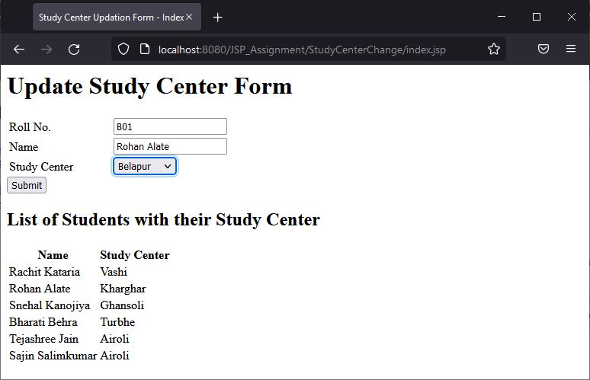

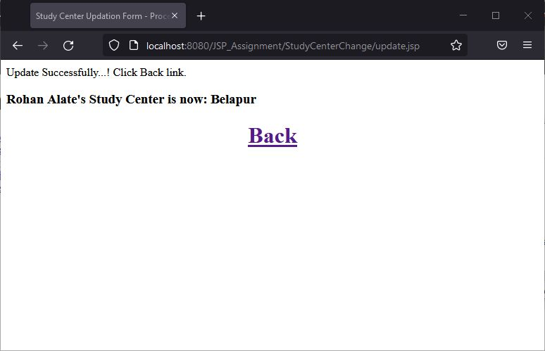

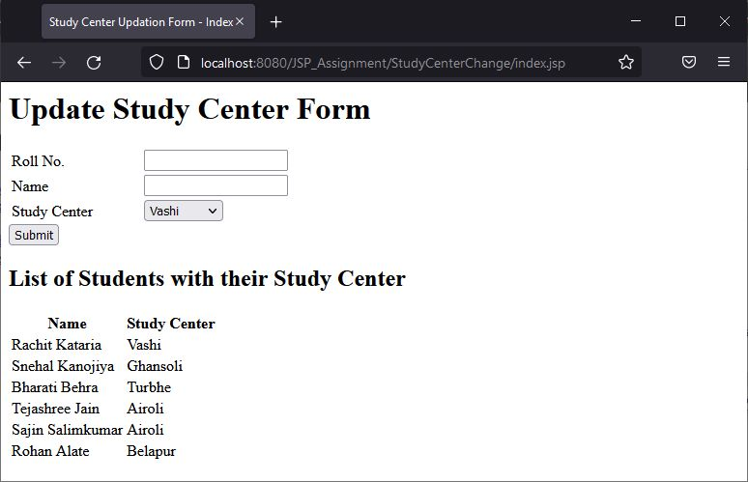

**Problem statement 6:** Write a JSP program that demonstrates the use of JSP declaration, scriptlet, directives, expression, header and footer.

**Solution:**

Main.jsp

<%@ page language=*"java"* contentType=*"text/html; charset=ISO-8859-1"*

pageEncoding=*"ISO-8859-1"*%>

<!DOCTYPE html>

<html>

<head>

<meta charset=*"ISO-8859-1"*>

<title>Jsp Example</title>

</head>

<body>

<body>

<%@ include file = *"header.jsp"* %>

<center>

<%! int data=50; %>

<%= "Value of the variable is:"+data %>

<%!

double circle(int n){ return 3.14*n*n;}

%></br>

<%= "Area of circle is:"+ circle(3) %></br>

<%!

int rectangle(int l,int b){ return l*b;}

%>

<%= "Area of rectangle is:"+rectangle(3,4

) %></br>

<%!

int perimeter(int x,int y){

int peri=2*(x+y);

return peri;}

%>

<%= "Perimeter of rectanlge:"+perimeter(5,6

) %> </br>

<p>Thanks for visiting my page.</p>

</center>

<%@ include file = *"footer.jsp"* %>

</body>

</html>

Header.jsp

<%@ page language=*"java"* contentType=*"text/html; charset=ISO-8859-1"*

pageEncoding=*"ISO-8859-1"*%>

<!DOCTYPE html>

<%!

int pageCount = 0;

void addCount() {

pageCount++;

}

%>

<% addCount(); %>

<html>

<head>

<title>JSP declaration, scriptlet, directives, expression, header and footer Example</title>

</head>

<body>

<center>

<h2>The include Directive Example</h2>

<p>This site has been visited <%= pageCount %> times.</p>

</center>

<br/><br/>

</body>

</html>

Footer.jsp

<%@ page language=*"java"* contentType=*"text/html; charset=ISO-8859-1"*

pageEncoding=*"ISO-8859-1"*%>

<!DOCTYPE html>

<html>

<head>

<meta charset=*"ISO-8859-1"*>

<title>Insert title here</title>

</head>

<body>

<br/><br/>

<center>

<p>Copyright 2021</p>

</center>

</body>

</html>

**Output:**

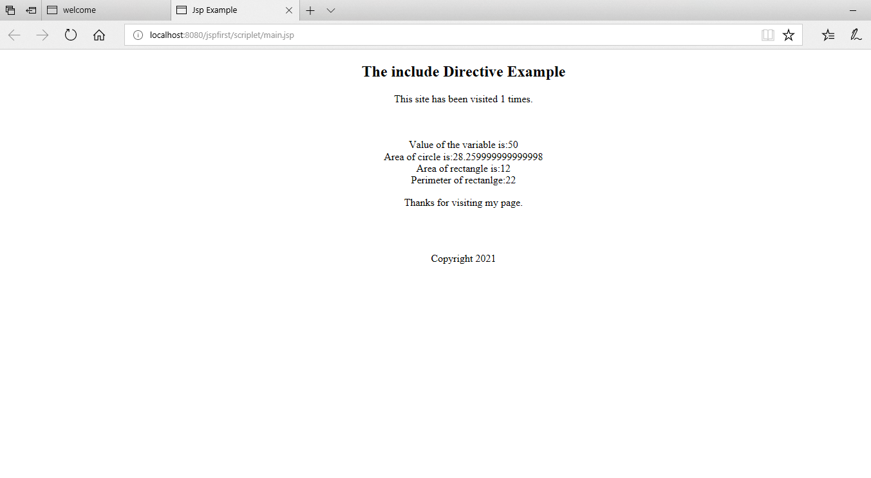

**Problem statement 7:** Write a JSP program that demonstrates the use of session or cookies.

**Solution:**

Cookieexample.jsp

<%@ page language=*"java"* contentType=*"text/html; charset=ISO-8859-1"*

pageEncoding=*"ISO-8859-1"*%>

<!DOCTYPE html>

<html>

<body>

<form action = *"main.jsp"* method = *"GET"*>

First Name: <input type = *"text"* name = *"first_name"*>

<br />

Last Name: <input type = *"text"* name = *"last_name"* />

<input type = *"submit"* value = *"Submit"* />

</form>

</body>

</html>

Main.jsp

<%@ page language=*"java"* contentType=*"text/html; charset=ISO-8859-1"*

pageEncoding=*"ISO-8859-1"*%>

<!DOCTYPE html>

<%

// Create cookies for first and last names.

Cookie firstName = new Cookie("first_name", request.getParameter("first_name"));

Cookie lastName = new Cookie("last_name", request.getParameter("last_name"));

// Set expiry date after 24 Hrs for both the cookies.

firstName.setMaxAge(60*60*24);

lastName.setMaxAge(60*60*24);

// Add both the cookies in the response header.

response.addCookie( firstName );

response.addCookie( lastName );

%>

<html>

<head>

<title>Setting Cookies</title>

</head>

<body>

<center>

<h1>Setting Cookies</h1>

</center>

<ul>

<li><p><b>First Name:</b>

<%= request.getParameter("first_name")%>

</p></li>

<li><p><b>Last Name:</b>

<%= request.getParameter("last_name")%>

</p></li>

</ul>

</body>

</html>

**Output:**

